DAYANANDA SAGAR UNIVERSITY

#### Harohalli,Bengaluru-560114



A Project Report on

"SMART TRAFFIC MANAGEMENT TO REDUCE AMBULANCE DELAY"

Submitted in partial fulfilment of the requirements for the award of the degree BACHELOR OF TECHNOLOGY

in

ELECTRONICS AND COMMUNICATION ENGINEERING

by

RAVI KUMAR (ENG21EC0095)

UDAY KIREN REDDY G (ENG21EC0133)

SYED OMAR (ENG21EC0127)

MAHENDRA B (ENG20EC0048)

Under the guidance of

DR . SUP RAJA EDURU

Assistant professor

DEPARTMENT OF ECE,

SCHOOL OF ENGINEERING, DSU

Depai1ment of Electronics and Communication Engineering,

Dayananda Sagar University, Bengaluru 560114

Academic Batch:202 l Year:2025

**DAYANANDA SAGAR UNIVERSITY**



**School of Engineering Harohalli, Bengaluru-560114**

## Department of Electronics and Communication Engineering

*CERTIFICATE*

*This is to certify that the Project entitled "* S MART TRAFFIC MANAGEMENT TO REDUCEAMBULANCE DELAY *" has been successfully carried out by* **RAVI KUMAR(ENG21EC0095),UDAY KIREN REDDY G(ENG21EC133),SYED OMAR(ENG21EC0127) , MAHENDRA B[ENG20EC0045)** *.In partial fulfilment of the requirement for the award of the degree BACHELOR OF TECHNOLOGY in ELECTRONICS* & *COMMUNICATION ENGINEERING by DAYANANDA SAGAR UNIVERSITY during the*

*academic year 2024-25.*

Signature of Guide Signature of Co-Guide Signature of Coordinator

|  |  |  |
| --- | --- | --- |
| NAME | NAME | NAME |
| Designation , Dept. | Designation, Dept. | Designation , Dept. |
| of ECE | of ECE | of ECE |
| SoE-DSU, Bengaluru | SoE-DSU, Bengaluru | SoE-DSU, Bengaluru |

Signature of the Chairman

Dr. Arun Balodi

Dept. of ECE

SoE-DSU, Bengaluru

Signature of the Dean

Dr. Udaya Kumar Reddy K R SoE-DSU, Bengaluru

External Examiner:



Name Signature



Name Signature

##### DECLARATION

*We declare that the thesis entitled* ***"****"* S MART TRAFFIC MANAGEMENT TO REDUCE AMBULANCE DELAY***"*** *submitted to the Department of Electronics and Communication Engineering, School of Engineering, Dayananda Sagar University, Bengaluru, for the award of degree* " *Bachelor of Technology" in Electronics and Communication Engineering is a record of original work carried out by us under the guidance of* ***Dr. sup raja eduru , Assistant professor****, Dept. of ECE, Dayananda Sagar University, Bengaluru.*

*To the best of my knowledge, this work has not been submitted for award of any degree in any University or Institute .*

Date: Student Name:

Ill

##### ACKNOWLEDGEMENT

*The completion of my Phase-II .final year project brings a sense of great satisfaction, but it is never complete without thanking the people responsible for its successful completion.*

*First, we take this opportunity to express our sincere gratitude to the Management, School of Engineering , Dayananda Sagar University, for providing us with a great opportunity to pursue our Bachelor 's Degree in this Institution.*

*In particular we would like to thank* ***Dr. Udaya Kumar Reddy K R, Dean,*** *School of Engineering, Dayananda Sagar University for his constant encouragement and expert advice. It is a matter of immense pleasure to express our sincere thanks to* ***Dr. Arun Balodi , Chairman,*** *Department of Electronics and Communication Engineering, Dayananda Sagar*

*University for providing the right academic guidance that made our task possible.*

*We would like to thank our guide* ***Name, Designation ,*** *Department of Electronics and Communication Engineering, Dayananda Sagar University for sparing his/her valuable time to extend help in every step of our project work, which paved the way for smooth progress and fruiiful simulation of the project.*

*We would like to thank our Project Coordinators* ***Dr. Saara K* & *Dr. Mukti Chaturvedi,*** *Department of Electronics and Communication Engineering, Dayananda Sagar University and* ***all the staff members*** *of Electronics and Communication for their support.*

*We are also grateful to our family and friends who provided us with every requirement throughout the course.*

*We would like to thank one and all who directly or indirectly helped us in completing the Project work successfully.*

*Signature of Students*

**IV**

## ABSTRACT

The rapid increase in urban vehicular traffic has escalated congestion levels, especially during peak hours, severely impeding emergency response times. Ambulances, critical for saving lives in emergencies, often face delays due to inefficient traditional traffic management systems. This project presents a novel IoT-based Smart Traffic Management System designed to mitigate these issues by prioritizing ambulances in traffic. The system leverages advanced technologies like image processing, IoT, and real-time data analytics to dynamically adjust traffic signals. Real-time video feeds from cameras and audio inputs from microphones are processed to detect ambulances based on their visual and auditory signatures. An intelligent algorithm, using techniques like the Canny Edge Detector , identifies traffic density and emergency vehicles. Once an ambulance is detected, the system over Tides standard traffic light operations to provide a green signal along the ambulance's path, ensuring rapid and unintelTupted movement through congested areas.

This project is motivated by the pressing need for smarter urban traffic solutions. Increasing traffic congestion, delays in emergency medical assistance, and the limitations of traditional static traffic systems highlight the impo1tance of adaptive and intelligent systems. By utilizing IoT devices, sensors, and machine learning algorithms, the system not only reduces ambulance travel times but also improves overall traffic flow efficiency. The methodology involves data collection from webcams, sensors, and microphones to - analyze traffic density and detect emergency vehicles. Logical operations and decision­ making algorithms manage the traffic light states dynamically, switching between normal and ambulance-prioritized modes. For instance, the system follows a standard traffic light sequence during regular operations but immediately transitions to prioritize ambulances when detected. This decision-making is implemented using components like Raspberry Pi, Arduino boards, and audio detectors. Simulations were conducted using MATLAB and Simulink to validate the system's performance. The code dynamically adjusts signal states, ensuring a green light for ambulances while maintaining logical transitions for other traffic. Hardware components such as Raspberry Pi cameras, Arduino Mega 2560, and microphones integral to the real-time implementation.

#### Table of Contents:

* Introduction to Technology
* Literature Survey- (Related work done in last 5 years, minimum 15 research papers)
* Problem Statement
* Methodology
* Details of the components/simulation tools to be used
* Deliverables
* Expected Output based on understanding from literature survey
* Timelines
* Contribution of each member
* References
* Publications

###### **Introduction to Technology**

Long commutes and large delays in vehicle flow at crossings are the results of the expanding number of four-wheeled cars on metropolitan streets, which has greatly worsened traffic congestion, especially during peak hours. It becomes a very hazardous scenario when ambulances are delayed during crises due to the limitations of traditional traffic management systems that are not adaptable enough to change in real time. This problem is addressed by the proposed system, which introduces an intelligent, Internet of Things-based smart traffic management solution that prioritizes ambulances by dynamically changing traffic lights in response to real-time inputs. In addition to advanced technologies like image and audio processing, the device uses real-time video feeds and auditory data captured by strategically placed microphones to detect emergency vehicles. Yolo and other machine learning algorithms are used to detect ambulances and measure traffic density, allowing for prompt and precise decision-making. The device ensures quick and continuous mobility by overriding conventional traffic light logic to give an ambulance a green signal along its path once it is spotted.

Further more, under typical circumstances, the system works effectively by tracking vehicle density and adjusting signal timings appropriately to provide the least amount of disruption to n01mal traffic. A scalable and reasonably priced hardware configuration is created by combining microcontrollers, such as the Arduino nano CH340, with sensors and real-time control software. MATLAB and Simulink simulations verify that the technology can drastically cut ambulance delays while preserving smooth traffic flow.This intelligent infrastructure improves air quality, reduces fuel consumption, and eases traffic congestion, all of which contribute to sustainable urban development and emergency response efficiency. In the direction of safer, smarter, and more effective urban transpo1tation networks, this technology is a revolutiony move that will integrate with future smait city effo1ts and facilitate data-driven decision-making. It was suggested that lanes be automatically clean ed for ambulances using an RFID-based system. In dense urban ai·eas, roadside readers can identify RFID tags on ambulances, which causes traffic lights to turn green and offer a clear path, reducing delays and speeding up emergency response times [l]. Itwas suggested to employ traffic flow models to forecast and control congestion in a smait traffic system. In metropolitan locations, the system analyzes vehicle density and

###### flow rates to dynamically improve traffic signal timings, lowering waiting times and increasing overall traffic efficiency [2].

Additionally , a smait traffic management system based on the Internet of Things was created that uses sensors to gather real-time traffic data and adjusts traffic lights accordingly. The system seeks to increase road safety, reduce traffic jams, and expedite the cleai·ance of emergency vehicles such asemergency vehicles [3]. AI algorithms ai·e used to assess traffic trends and forecast congestion in a deep leai·ning - based smait traffic management system for smait cities. Additionally, by enabling proactive traffic control, the system enhances road safety, minimizes delays, and maximizes traffic flow across the city [4].

A smait traffic management system based on the Internet of Things (IoT) that uses connected sensors and gadgets to monitor traffic conditions. The goal of the system is to create safer and more effective urban transpo1tation networks by processing real-time data to dynamically control traffic lightsand provide precedence to emergency vehicles.[5] This study examined device-to-device (D2D) interactions in smait traffic systems based on the Internet of Things.It emphasizes how decentralized real-time information transmission promotes decision-making in traffic management, optimizes traffic flow, and improves data shai·ing when vehicles and infrastmcture communicate directly [6]

**Literature Survey**

Several researchers have explored intelligent traffic control systems aimed at reducing congestion and providing priority to emergency vehicles such as ambulances. Pandiaraj et al. [1]

proposed an RFID-based automatic lane clearance system that utilizes a wireless sensor network to provide a clear path for ambulances. Their system used a priority-based medium access control protocol to ensure real-time data transmission from emergency vehicles to traffic control systems. However, it suffered from limitations such as short-range RFID communication and signal interference in dense urban areas.

Sundru Rajeshwari et al. [2]

designed a smart traffic system using RFID and ZigBee technology to prioritize emergency vehicle movement, manage congestion, and even detect stolen vehicles. Their system demonstrated good results under controlled conditions, but its performance was constrained by the limited range and susceptibility to interference of ZigBee and RFID modules. Kar et al. [3]

developed an Arduino-based emergency vehicle and traffic management system that adjusted signal timing based on real-time traffic density. While their system improved emergency vehicle flow, it was highly dependent on the reliability and accuracy of traffic density sensors.

Mandal et al. [4]

implemented active RFID and GSM technology for traffic congestion monitoring. The long-range object detection and low power consumption were key strengths of this system, though its practical usage was hindered by the high cost and limited lifespan of active RFID tags. Shruthi and Vinodh [5]

proposed a priority-based traffic light controller using wireless sensor networks and fuzzy logic. Fuzzy logic provided better adaptability than fixed-time controllers, but its effectiveness relied heavily on expert configuration and rule tuning.

Shrikhande and Shende [6]

used embedded web technologies to allow traffic monitoring and control via web browsers. While offering real-time monitoring capabilities, their system faced practical issues such as high cost, inefficiency, and complications in updating the system regularly. Dabahade and Kshirsagar [7]

introduced an FPGA-based intelligent traffic controller that was cost-effective and reconfigurable. However, the FPGA system was complex to design and had performance limitations compared to more adaptive platforms.

Ahir et al. [8]

proposed a mobile application-based solution that turned red traffic lights green for ambulances by communicating directly with the signal controller. Despite demonstrating strong functionality, their system was found to be costly and vulnerable to technical issues such as privacy breaches and RFID communication failures. Ankush et al. [9]

presented a computer vision-based solution where vehicles were detected using image processing instead of traditional sensors. Their system showed promise but was limited by factors such as motion blur, changing lighting conditions, and complex vehicle interactions.

Finally, Krishnamoorthy and Manickam [10] implemented edge detection techniques in digital image processing and introduced a hybrid scheduling algorithm to manage congestion. Their system dynamically adjusted green light durations based on traffic conditions, using round-robin logic with dynamic time slicing. While innovative, this approach faced challenges such as large data volumes, real-time performance, and the placement of surveillance cameras.

**Problem statement**

* Urban traffic congestion delays ambulances, impacting response times and efficiency. Current signals lack real-time adaptability. An IoT system is needed to monitor traffic, prioritize emergency vehicles , and adjust signals dynamically to reduce delays.

**Methodology (block diagram)**

Emergency vehicle is detected

Image signal processing and emergency vehicle detection

Emergency vehicle is detected

Capture the image of emergency vehicle at a certain distance from the traffic signal

Emergency vehicle detection using YOLO V8 model

Change the traffic light signal to green

Continue with the operation of automatic traffic signaling system based on traffic density

Emergency vehicle not detected

Capture the image of the emergency vehicle at the traffic signal

Emergency vehicle not detected

Continue the traffic light signal to green

**Methodology**

1. Capture the image of emergency vehicle at a certain distance from the traffic signal

The system captures images of oncoming vehicles at a predefined distance from the traffic signal using a camera.

1. Emergency vehicle detection using YOLO VS model

The captured image is processed using the YOLO V8 deep learning model to identify whether an emergency vehicle (e.g., ambulance) is present.

1. Emergency vehicle is detected

If the YOLO model detects an emergency vehicle, the system proceeds to give it priority.

1. Change the traffic light signal to green

The traffic light is immediately turned green to allow the emergency vehicle to pass through without stopping.

1. Capture the image of the emergency vehicle at the traffic signal

A second image is taken as the emergency vehicle reaches the signal, for fi.nther confirmation.

1. Image signal processing and emergency vehicle detection

This second image is analyzed again to verify whether the emergency vehicle is still present at the intersection.

1. Emergency vehicle not detected

Ifthe vehicle is no longer detected, it means it haspassed the signal.

1. Continue the traffic light signal to green

The system continues the green signal for a shot time to ensure complete passage before resuming normal operation.

1. Emergency vehicle not detected

If the YOLO model doesn't find any emergency vehicle in the initial image, the system decides that no priority is needed.

1. Continue with the operation of automatic traffic signaling system based on traffic

The system switches back to standard automatic signal control, adjusting lights based on real-time traffic flow instead of emergency detection.

**Details of the components/simulation tools to be used**

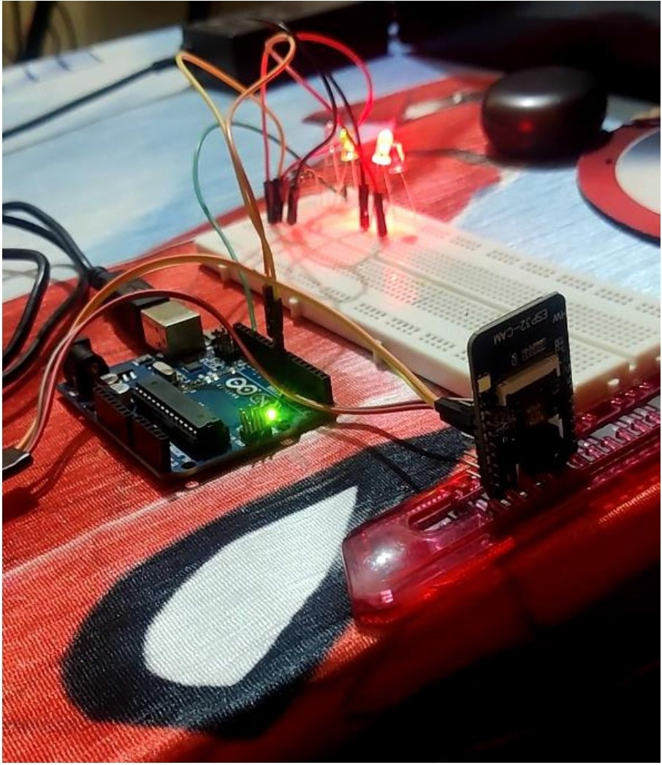

**Details of the components/simulation tools to be used**

Hardware Components

1. Arduino Uno
   * Role: Serves as the central microcontroller unit for managing communication and control.
   * Functionality :
     + Interfaces with the ESP32-CAM and other peripherals (e.g., LEDs, traffic light system).
     + Receives processed signals or commands from MATLAB/Simulink via serial communication (optional).
     + Can handle basic logic for traffic control and override systems.
   * Connectivity:
     + Uses digital and analog I/O pins to interact with actuators and sensors.
     + Optionally interfaces with Bluetooth or Wi-Fi modules for wireless communication.
2. ESP32 Camera Module
   * Role: Primary image and video capturing hardware.
   * Functionality :
     + Captures live video feeds of traffic intersections.
     + Sends images or streams for processing either locally or to an external processor (e.g., MATLAB).
     + Can perform lightweight on-board image analysis using MicroPython or Arduino IDE.
   * Connectivity:
     + Built-in Wi-Fi and Bluetooth supp01t for remote streaming.
     + Can communicate with Arduino Uno via serial or I2C.
3. Image Sensors (Integrated with ESP32-CAM)
   * Role: Convert optical input into digital signals (frames).
   * Functionality :
     + Segment video into frames for real-time or batch processing.
     + Suppo1ts edge detection and pattern recognition (ambulance logo, shape, or flashing light).
   * Processing :
     + Output can be transferred to MATLAB/Simulink for deep image processing and traffic analysis.
4. Traffic Light System (Prototype)
   * Role: Mimics a real-world traffic signal for simulation and testing.
   * Components:
     + LEDs for red, yellow, and green signals.
     + Relay modules or transistor switches to simulate control.
     + Powered and controlled via Arduino Uno outputs.

###### Software and Simulation Tools

1. MATLAB/Simulink

* + Simulation Environment :
    - Models traffic junctions and signal logic using block diagrams.
    - Integrates logical flow for dynamic traffic control.

###### Image and Video Processing :

* + - Uses Canny Edge Detection for analyzing vehicle and ambulance movement.
    - Performs histogram analysis or frame differencing to estimate traffic density.

###### Algorithm Development :

* + - Logical blocks simulate decision-making :
      * Traffic light duration adjustment based on density.
      * Priority oveITide when an ambulance is detected.

###### Logical Subsystems in Simulink Without Ambulance (Normal Mode)

* + Standard Cycle Timing:
    - Red: 5 seconds
    - Green: 5 seconds

###### Function :

* + - Ensures fair distribution of green time for each direction.
    - Cycle repeats based on fixed timing or minor density adjustments.

###### With Ambulance (Priority Mode)

* + Ambulance Detection :
    - Ifan ambulance is identified in a paiticular direction:
      * Immediate oveITide of cmTent cycle.
      * Green light activated in ambulance's path.
      * Maintains green until safe passage is confirmed.

###### Post-Passage Recovery :

* + - Returns to standai·d cycle after delay or confirmation.

###### **Deliverables**

1. Final Report
   * Comprehensive project documentation including:
     + Problem statement.
     + Objectives and scope of the project.
     + Literature smvey and references.
     + Proposed methodology with detailed explanations.
     + Simulation results and findings.
     + Conclusion and future scope.
2. Simulation Results
   * MATLAB/Simulink models demonstrating :
     + Traffic light control for both normal and emergency scenarios.
     + Real-time ambulance detection and priority mechanism.
     + Traffic density estimation and its impact on signal operation.
   * Screenshots or video recordings of the simulation.
3. Source Code
   * Complete and well-documented source code for:
     + Ambulance detection algorithms (image/audio processing).
     + Traffic light logic implementation (in MATLAB, Python, or embedded systems code).
   * Comments and explanations for reproducibility.
4. Hardware Implementation
   * Functional prototype demonstrating the system's working, including:
     + Arduino setups.
     + Esp32 camera for real-time video input.
     + Traffic light simulation (using LEDs or virtual components).
   * Integration of all hardware components.
5. Presentation
   * Slide deck summarizing :
     + Project introduction and motivation.
     + Technical approach and components.
     + Simulation and hardware demonstration.
     + Key findings and conclusions.

* Includes visuals like block diagrams, flowcharts, and screenshots.

**Expected Output based on understanding from literature survey**

This section addresses the accuracy performance of the proposed model. A total of 22 different experiments, 10 of which are pre-trained, while the other 10 are non-pre-trained. The rest 2 experiments are called universal models (i.e., pre-trained vs non-pre-trained). The YOLOv8 model is used for better object detection, and these experiments show how this model uses the bounding box in red around the ambulance vehicles.

A dataset consisting of various images of ambulances from different countries and environments is used to train the model. Each image has been annotated with bounding boxes and labeled as "Ambulance" to train the YOLOv8 model for object detection. The ambulances in the dataset vary in design, color, and background to ensure the model can generalize well across different real-world scenarios. This diverse and labeled dataset is crucial for teaching the detection model to accurately identify ambulances under varying conditions like lighting, angles, and surroundings. The dataset forms a foundational part of the project, enabling the system to recognize ambulances with high accuracy during real-time traffic monitoring.

In Fig. 5, the scenario when no ambulance is detected by the system is shown. The screen displays a normal car, and the ambulance detection software correctly identifies that there is no ambulance present. As a result, the message "NO AMBULANCE – RED LIGHT" appears prominently at the top of the detection window, along with a red indicator. This indicates that the traffic light would remain red, preventing vehicles from moving and ensuring that priority is reserved only for emergency vehicles like ambulances. This image clearly shows that the system is capable of distinguishing between ambulances and other vehicles, ensuring reliable decision-making for automated traffic control based on real-time object detection.

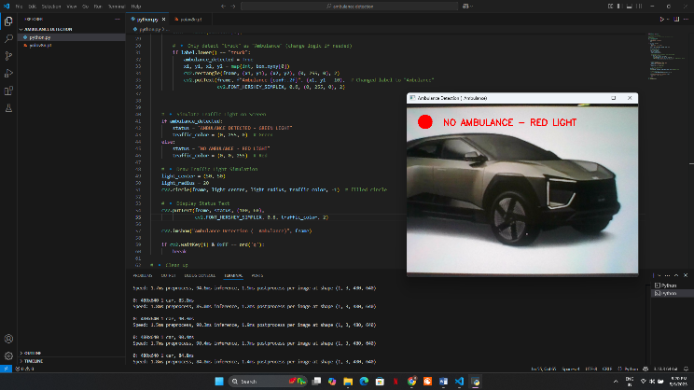

Fig. 5 Model performance in not detecting an ambulance

In Fig. 5, the scenario when no ambulance is detected by the system is shown. The screen displays a normal car, and the ambulance detection software correctly identifies that there is no ambulance present. As a result, the message "NO AMBULANCE – RED LIGHT" appears prominently at the top of the detection window, along with a red indicator. This indicates that the traffic light would remain red, preventing vehicles from moving and ensuring that priority is reserved only for emergency vehicles like ambulances. This image clearly shows that the system is capable of distinguishing between ambulances and other vehicles, ensuring reliable decision-making for automated traffic control based on real-time object detection.

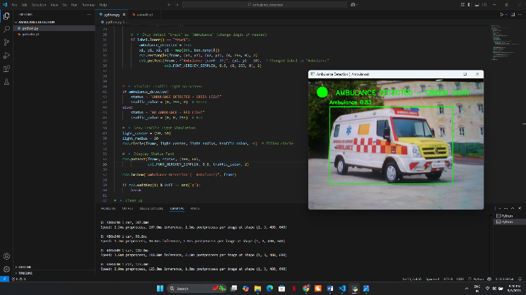

Fig. 6 Model performance on detecting an ambulance

In Fig. 6, a successful detection of an ambulance by the system is observed. In the detection window, the YOLOv8 model has identified an ambulance with a confidence score of 0.55, which is displayed along with a green bounding box around the vehicle. At the top of the window, the message "AMBULANCE DETECTED – GREEN LIGHT" is clearly shown with a green indicator. This indicates that the system has recognized the ambulance and would trigger a green traffic light to allow the ambulance to pass through the intersection without delay. This image highlights the system’s effectiveness in detecting emergency vehicles in real-time and immediately responding by updating the traffic signal status, demonstrating the practical working of an intelligent traffic management solution.

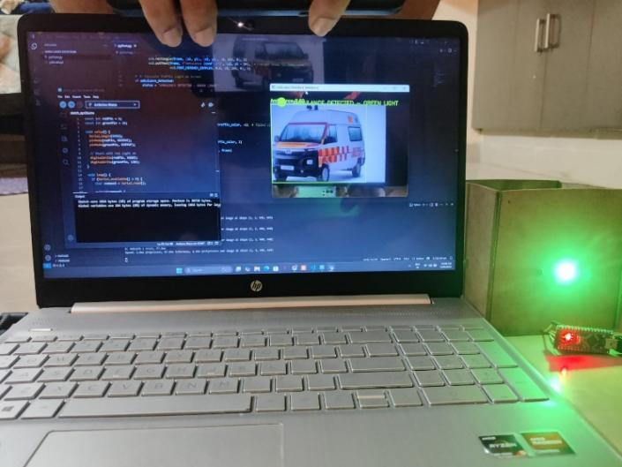

Fig. 7 Testing the model performance

The live implementation of an ambulance detection system where both software and hardware components are working together is shown in Fig. 7. On the laptop screen, Python code is running to process a video feed using a YOLOv8 model to detect ambulances in real-time. Alongside, Arduino Nano code is open, which is programmed to control an LED based on the detection results received through serial communication. In the detection window, an ambulance is identified, and the system displays the message "AMBULANCE DETECTED – GREEN LIGHT," confirming successful detection. As a result, the green LED connected to the Arduino Nano is glowing, indicating that the traffic light would turn green to allow the ambulance to pass. This picture effectively captures the integration of computer vision (software side) with physical output control (hardware side) for smart traffic management.

Timelines

Month 1: Problem Identification and Research

Week 1:

* Define the problem: Ambulance delays due to traffic congestion.
* Conduct a literature review on existing traffic management systems.
* Identify the role ofioT and AI in dynamic traffic management. Week 2-4:
  + Analyze traffic patterns and collect initial data (case studies, urban traffic models).
  + Define project objectives and finalize system requirement s (hardware/software).

Month 2 : System Design and Initial Implementation Week 5-6:

* + Develop the methodology:
  + Audio processing for ambulance siren detection.
  + Image processing for traffic density analysis and vehicle detection.
  + Design system architecture and block diagrams. Week 7-8:
    - Select and procure hardware : Arduino, RaspbeITy Pi, cameras, microphones, sensors.
    - Begin implementation:
    - Program initial algorithms for audio and image processing.
    - Integrate sensors for data collection. Month 3 : Full Implementation and Testing

Week 9-10:

* + - Complete integration of hardware and software components.
    - Implement traffic signal control logic based on emergency detection. Week 11-12 :
    - Run simulations (e.g., MATLAB/Simulink) to validate system behavior :
    - Test normal traffic scenarios.
    - Test emergency vehicle prioritization.

**Contribution of each member**

1. Ravi Kumai·(ENG21EC0095)

Responsibilities :

* + Lead the problem identification phase and research literature review.
  + Oversee audio processing implementation to detect ambulance sirens.
  + Contribute to performance analysis and system optimization.

1. Syed Omar (ENG21EC0127) Responsibilities :
   * Design and implement image processing techniques (e.g., Canny Edge Detector).
   * Develop algorithms for identifying traffic density and emergency vehicles.
   * Assist with hardware integration, especially camera-related setups.
2. Uday Kiran Reddy G (ENG21EC0133) Responsibilities :
   * Manage hardware procurement and setup, including Arduino,and sensors.
   * Implement signal control mechanisms for real-time traffic adjustments.
   * Test system functionality during the simulation phase.
3. Mahendra B (ENG20EC0048) Responsibilities :
   * Focus on integrating IoT components and ensuring data flow between devices.
   * Document the system design and assist with block diagram development.
   * Lead the final presentation preparation and repo1ting.

Conclusion:

This smait traffic control system provides an efficient solution for reducing delays faced by emergency vehicles at traffic signals. By integrating real-time image capture and advanced object detection using the YOLO V8 model, the system can accurately identify emergency vehicles such as ambulances, fire trucks, or police cai·s from a distance. Upon detection, it dynamically oveITides the standai·d traffic signaling system to prioritize the movement of these vehicles by switching the light to green.

The system further confirms the vehicle 's presence at the signal to maintain accurate control and avoid unnecessai·y disruptions. Ifthe emergency vehicle is not detected at any stage, the system reverts to the n01mal traffic management process, ensuring seamless flow for other vehicles.

This intelligent approach not only minimizes ambulance response time but also enhances overall road safety, improves traffic efficiency, and can be integrated into existing urban smait traffic infrastructures. Its automated nature reduces the need for manual intervention, making it a scalable and reliable solution for modem cities.

Future Scope:

* Integration with GPS and loT Devices:

Emergency vehicles can be equipped with GPS and IoT modules to directly communicate with traffic signals, further increasing detection accuracy and coordination.

###### Support for Multiple Intersections:

Expanding the system to cover a network of traffic signals allows continuous priority routing for emergency vehicles across multiple junctions.

###### Use of SG Communication:

With ultra-low latency, 5G networks can enable faster real-time communication between vehicles and traffic infrastructure.

###### Machine Leaming-Based Traffic Prediction:

Incorporating AI models to predict traffic congestion patterns can help optimize signal timing even beyond emergency situations.

###### Integration with Smart City Platforms:

The system can be a pait of a lai·ger smait city ecosystem, contributing to centralized traffic monitoring, data analytics, and emergency response planning.

###### Voice and Audio Signal Detection:

Future systems could include siren sound detection to complement image processing, improving recognition even in low-visibility conditions.

###### Cloud-Based Data Logging and Analytics:

Storing detection and signal data in the cloud could help analyze system performance , vehicle flow, and response times for further improvements.

###### Autonomous Vehicle Compatibility:

As autonomous emergency vehicles emerge, the system could be adapted to interact with them directly, ensuring uninteITupted passage.

References

* + Pandiaraj, K., et al. "RFID Based Automatic Lane Clearance for Ambulance." 2021 International Conference on Advance Computing and Innovative Technologies in Engineering (ICACITE). IEEE, 2021.
  + Kamdar, Arihant, and Jigarkumar Shah. "Smart traffic system using traffic flow models." 2021 International Conference on Artificial Intelligence and Smait Systems (ICAIS). IEEE, 2021.Rachana K P, Aravind R, Ranjitha M, Spoo1thi Jwanita, Soumya K, 2021, IOT Based Smait Traffic Management System, INTERNATIONAL JOURNAL OF ENGINEERING RESEARCH & TECHNOLOGY (IJERT) NCCDS -2021 (Volume 09 -Issue 12).
  + Lingani, Guy M., Danda B. Rawat, and Moses Gai·uba. "Smait traffic management system using deep leai·ning for smait city applications." 2019 IEEE 9th annual computing and communication workshop and conference (CCWC). IEEE, 2019.
  + Javaid, Sabeen, et al. "Smait traffic management system using Internet of Things." 2018 20th international conference on advanced communication technology (ICACT). IEEE, 2018 S. N. M ahea la ni, K. B. Ma laka nd and R.

M ana ker, "Device to device intera ction ana lysis i n loT based Smart Traffic

M anagement System: An experimenta l approach," 2016 Symposi u m on Colossa l Data Ana lysis and Networking (COAN), Indore, 2016, pp. 1-6.

Doi:l0.1109/CDAN.2016.7570909

* + Yang, Bo, Ranching Zheng, Keisuke Shimon, Tsutomu Kazakova'd Kimiko Nakano. "Evaluation of the effects of in-vehicle traffic lights on driving performances for unsignalized intersections." IET Intelligent Transpo1t Systems! 1, no. 2 (2017).
  + Chandramana , J., Nagarajan, R., Satheesh Kumai-, K., Ajith Kumai-, N. , Gopinath, P. A., & Ranjith Kumai-, S. (2017). Intelligent smait home automation and security system using Arduino and Wi-fi. International Journal of Engineering and Computer Science.
  + IBM Bluemix (2018) Build a cloud-ready temperature sensor with the Arduino Uno and the IBM Watson IoT Platform.
  + A.Balamumgan , G.Navin Siva Kumai-, S. Raj Thilak, P. Sivakumai·(2015) Automated emergency system in ambulance to control traffic signals, International Journal of Engineering And Computer Science, 4(4) pp. 11533- 11539.
  + M. Banzi and M. Shiloh (2015) Getting Staited with Arduino: The Open Source Electronics Prototyping Platform, Maker Media, Inc. (3rd edition).

**Publications**

Steps for Publication Prepare a Research Paper :

* Format the paper according to the target publication's guidelines.
* Key sections to include :
* Abstract: A brief summary of the project, objectives, methodology, and results.
* Introduction : Problem statement, relevance , and objectives.
* Methodology : Detailed description of the system design and techniques used (audio/image processing , IoT, etc.).
* Results and Analysis: Simulation results, perfo1mance metrics, and discussion of findings.
* Conclusion and Future Work: Summarize the impact and propose potential enhancements.
* References: Cite all sources used in the research. Select a Suitable Journal or Conference :
* Choose a venue relevant to IoT, AI, traffic management , or smait city solutions. Submit Your Paper :
* Follow the submission guidelines and ensure all co-authors review the final draft.
* Include acknowledgments to your guide and institution. Respond to Reviewer Feedback :
* Revise the paper as per the reviewer comments and resubmit if needed. Suggested Conferences and Journals

Conferences:

* IEEE International Conference on Intelligent Transpo1tation Systems (ITSC).
* International Conference on Artificial Intelligence and Smait Systems (ICAIS).
* International Conference on IoT and Smait Cities. Journals:
* IEEE Transactions on Intelligent Transpo1tation Systems.
* Springer Journal of Transportation Technologie s.
* Elsevier Transportation Reseai·ch Pait C: Emerging Technologies.
* International Journal of Engineering Reseai·ch & Technology (IJERT).

